Name: Quang Huynh

Unit 3 Video Guide – Heimler’s History

Land-Based Empires 1450-1750

*Major Theme: How did land-based empires gain and maintain power from 1450-1750?*

Match each empire with its geographic location

|  |  |
| --- | --- |
| D 1. Qing | A. Northern India |
| A 2. Mughal | B. North America |
| E 3. Ottoman | C. West Africa |
| F 4. Safavid | D. East Asia |
| C 5. Songhai | E. Middle East, Eastern Europe, North Africa |
| B 6. Aztec | F. Persia |

How did land-based empires CONSOLIDATE power?

**Centralizing and Bureaucracy**

7. What is a bureaucracy?

A bureaucracy is a group of people employed by the government who carried out the will of the Emperor.

8. Explain each example of centralizing power

* **Qing Dynasty – civil service exam**

The civil service exam is an example of centralizing power because you had to pass the exam to work with the government. People who passed the examination would both think and believe in the same things.

* **Ottoman Empire – devshirme system**

The devshirme system forced Christian boys who were in poverty to serve in the Ottoman’s military and their bureaucracy. The boys were from southern Europe and Balkans. The boys were educated thoroughly in politics, art and philosophy. After their education, some of the boys joined the Janissaries, bureaucratic workers or high-ranking government officials. They were very loyal to the Sultan.

* **Aztec Empire – tribute system**

The tribute system did not centralize power through bureaucracy. The tribute system relied less on centralized power. This system meant that people that lived on land of the landlord owed goods to the conquerors on a regular basis. Due to this system, the Aztecs could rule a diverse Empire without being directly involved.

**Taxes**

9. How did bureaucracies collect taxes? Explain each method used.

* **Mughal Empire – zamindars**

A group of bureaucrats, called Zamindars went out to various places in the empire to collect taxes based on land holdings or production.

* **Ottomans – tax farming**

Instead of the government collecting the taxes, there was a group of people that collected the taxes from people. This group of tax collectors are called tax farmers. They are told the amount of money that needed to collect, but many of them usually collected a little more than they needed.

* **Aztecs – tribute states**
* Each one of the tribute states had different tribute lists which outlined the kinds of goods they wanted from those places. The items varied throughout location and climates. This would include foods, goods and slaves.

**Elite Soldiers**

10. How did land-based empires get soldiers? Explain each.

* **Ottomans – Janissaries**

Janissaries are enslaved Christian who are very educated and very wee trained. They were also very loyal to the Sultan.

* **Safavids – Ghulams**

Ghulams were very loyal to the Shah. The Ghulams were taken from minority and slave populations like the Armenians and the cirassians.

* **Aztecs – slave soldiers**

The Aztecs had an elite squad made up of enslaved people.

How did land-based empires LEGITIMIZE power?

**Religion**

11. **How did rulers use religion to unify empires and justify their rule?**

Rulers would use religion to unify empires and justify their rule by saying that the rulers are the God’s men on earth, and they are carrying out God’s will in his action.

12. **How did religion lead to conflicts?**

* **Christianity –** The Protestant Reformation led to a lasting split between Catholics and Protestants. The European rulers had to decide whether their kingdom was going to be either Catholic or Protestant. This would lead to many disputes.
* **Islam –** The Ottoman Empire and Safavid Empire were different Muslims. The Ottomans were Sunnis and the Safavids were Shia. They would have many disputes over the border territory, and the conflicts were deeply religious.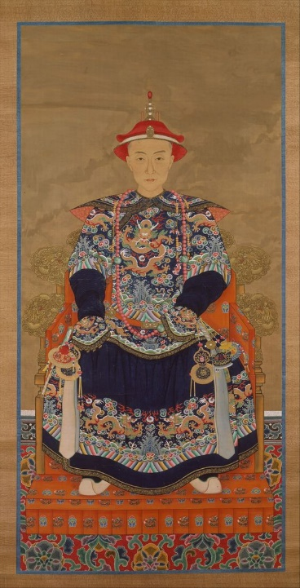

**Art**

13. **How did rulers use works of art to legitimize their power?**

Officials in China’s Qin Dynasty would commission portraits of their emperors and high officials. As you pass by the paintings enough, people would start recognizing that the person is in charge.

*Portrait of Qianlong, Emperor Qing Dynasty*

**Monumental Architecture**

14. How did rulers use monumental architecture to legitimize their power?

Rulers would use monumental architecture to legitimize their power through building a huge building as a tomb. Shah Jahan built a tomb for his wife, and he wanted to let everyone know that he was great and that he was in charge.

15. **Identify the buildings shown in the photos below.**

The first photo is the Taj Mahal, which was a tomb for Shah Jahan’s wife. The second photo was the palace at Versailles. This was built as a tomb for Louie the 14th wife.

